**Horizontal Abstract Panel Metal Wall Art**

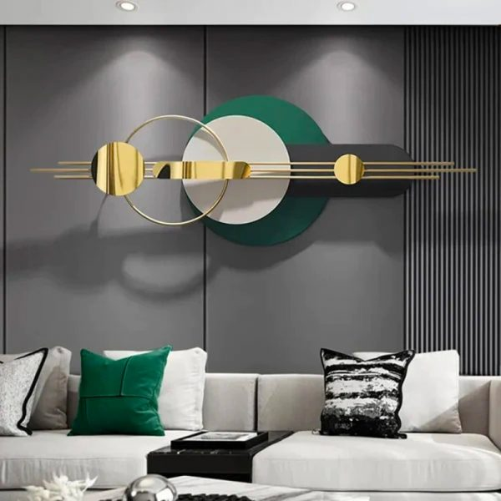Horizontal abstract panel metal wall art is a captivating decor piece that combines modern design with industrial elegance. Crafted from high-quality metal, these panels often feature dynamic patterns, textures, or abstract motifs, showcasing a blend of brushed, polished, or painted finishes. The elongated horizontal format makes it ideal for accentuating wide walls in living rooms, dining areas, or hallways, creating a sense of movement and visual flow. Its durable material and contemporary aesthetic make it both a striking focal point and a lasting addition to any interior, effortlessly elevating the ambiance with a touch of artistic sophistication.